Airgap Server SOP

The data contained in this document shall not be duplicated, used, or disclosed in whole or in part for any purpose. If a contract is awarded to chosen parties because of or in connection with the submission of this data, the client or prospective client shall have the right to duplicate, use, or disclose this data to the extent provided in the contract. This restriction does not limit the client’s or prospective client’s right to use the information contained in the data if it is obtained from another source without restriction. The data subject to this restriction is contained in all marked sheets.

HCL has more than 200 offices worldwide. Addresses, phone numbers, and fax numbers are listed on the HCL website at www.hcltechsw.com.

Copyright © 2024 HCL Tech. All rights reserved.

Table of Contents

1 Introduction 6

2 BigFix Installation On Airgap Server 6

3 Gather BES Support 7

4 Gather Other Sites 7

5 File Downloads ……………………………………………………………………………………………………………………………………………………………….

Introduction

* [Overview](https://help.hcl-software.com/bigfix/9.5/platform/Platform/Config/c_airgap_tool_introduction.html)

In an air-gapped environment where a secure network is physically isolated from insecure networks, such as the public Internet or an insecure local area network, and the computers on opposite sides of the air gap cannot communicate, to download and transfer files to the main BigFix server, you can use the Airgap utility and the BES Download Cacher utility.

* [Requirements](https://help.hcl-software.com/bigfix/9.5/platform/Platform/Config/c_airgap_tool_Req.html)

When your BigFix server is installed in an air-gapped environment where a secure network is physically isolated from insecure networks, such as the public Internet or an insecure local area network, and the computers on opposite sides of the air gap cannot communicate, you need a workstation that has access to the public Internet to download Fixlets site contents using the Airgap tool, and to download files referenced in the Fixlets action scripts.

BigFix Installation on Airgap Server

1. Preparation

Prerequisites

* Ensure you have the installation media (BigFix Server installer) and all necessary patches or updates.
* Acquire the license authorization file (license.pvk, lincense, actionsite.afxm, etc) from HCL BigFix.
* Prepare the air-gapped server with the required operating system and dependencies installed.

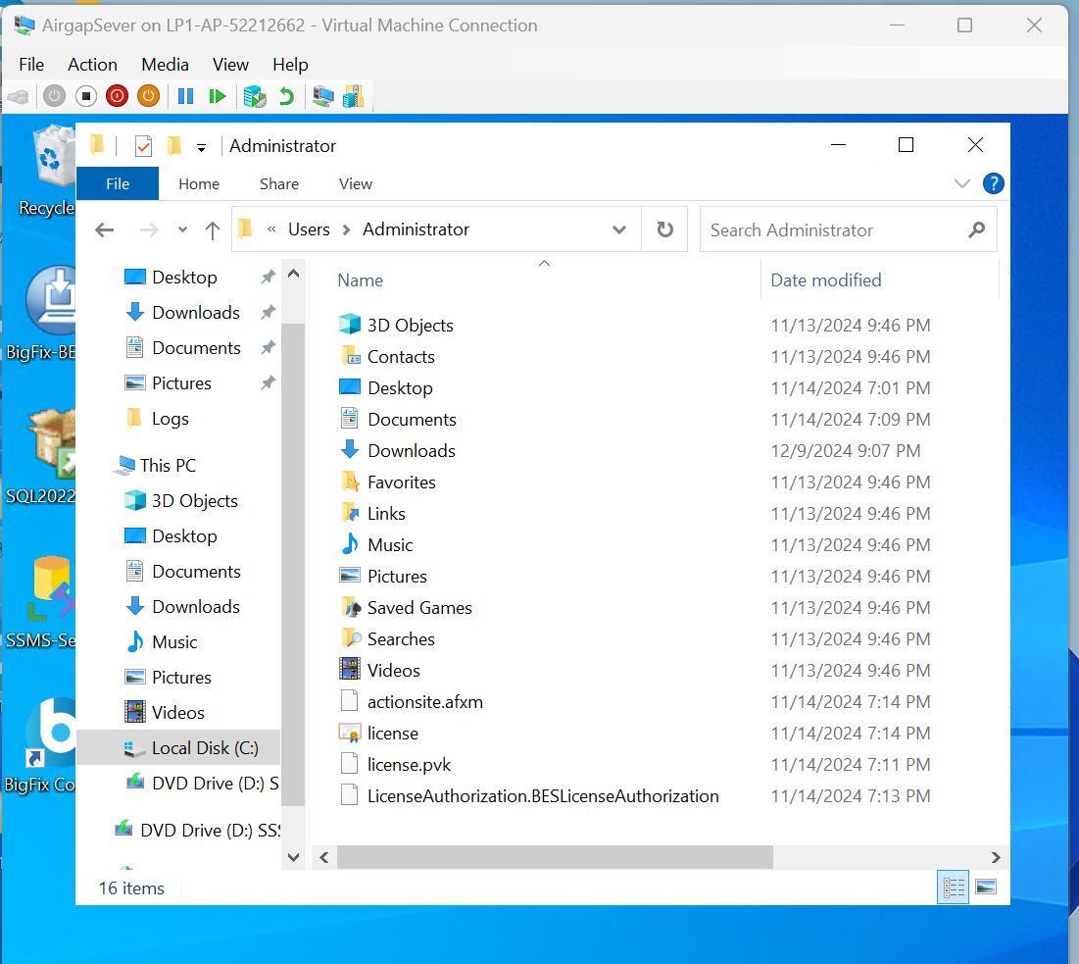

Transfer Required Files

* From a machine with internet access:
  + Download the BigFix installer for your platform (Windows or Linux).
  + Download required patches or hotfixes.
  + Ensure you have access to the license certificate.
* Use a secure method to transfer these files to the air-gapped server, such as a USB drive.

Install BigFix Server

For Windows

1. Run the Installer:
   * Transfer the BigFix-BES-Server-<version>.exe file to the air-gapped server.
   * Run the installer with administrator privileges.
2. Follow Installation Prompts:
   * Choose the installation directory.
   * When prompted for the license certificate, provide the path to the license.crt file.
3. Database Setup:
   * Choose to use either the default SQL Server Express or an existing database (SQL Server Standard/Enterprise).
   * Ensure the database is set up locally or accessible from the air-gapped server.
4. Finalize Installation:
   * Complete the installation wizard. BigFix Server will initialize locally.

BigFix Install Wizard

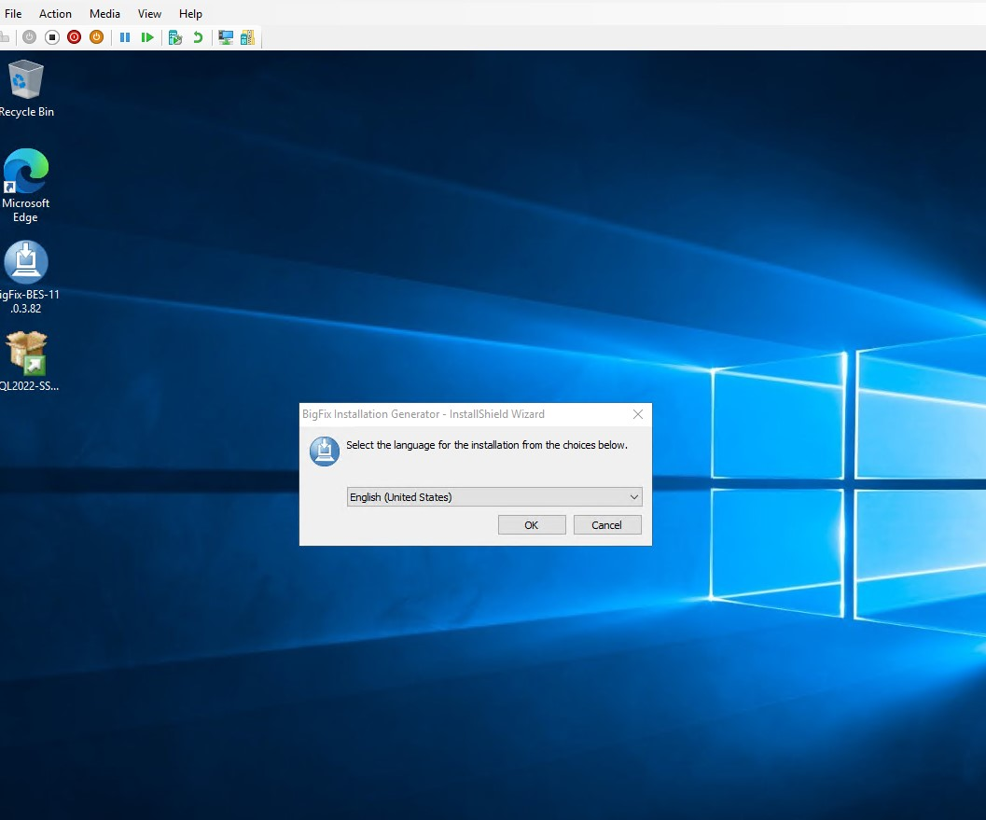

INSTALLATION COMPLETED

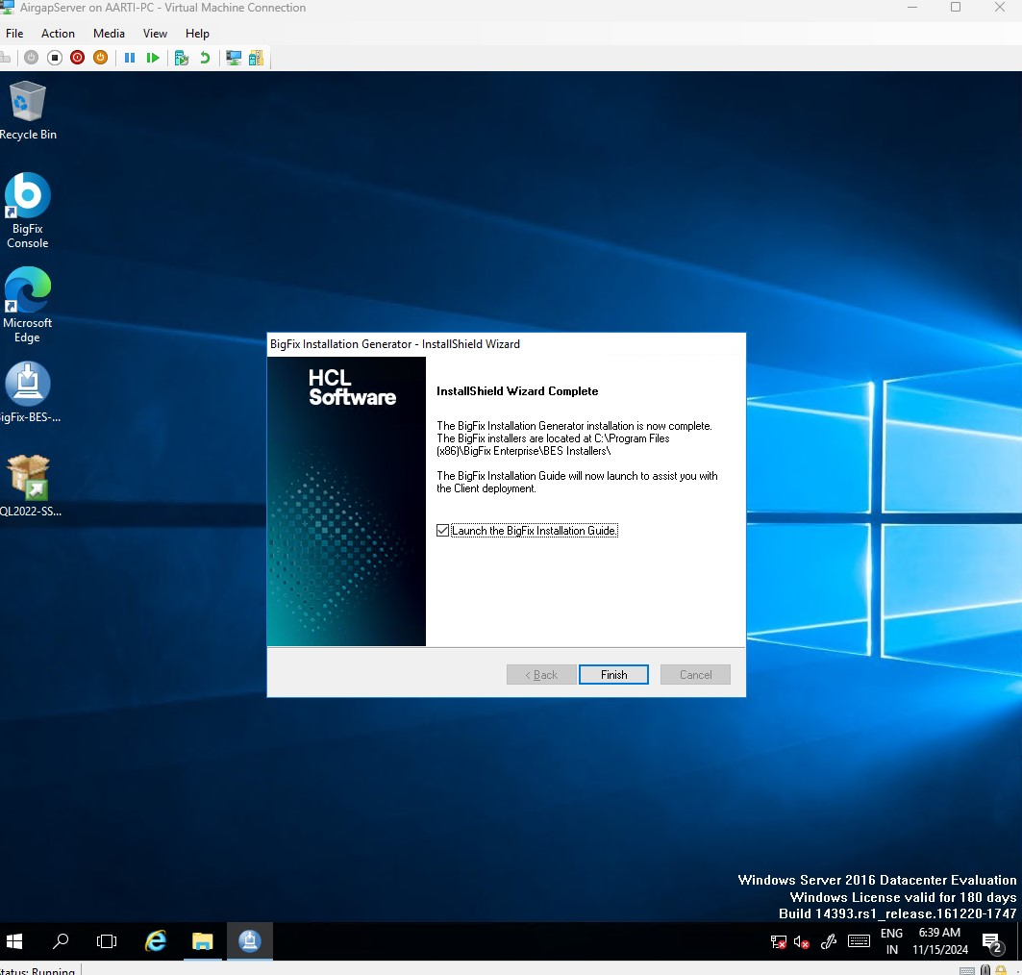

Gather BES Support

Prerequisites

* Download Airgap Tool Utilities from download.bigfix.com on the machine which has internet and extract it.
* Then Go to console look for the content in BES Support Site it should be 0

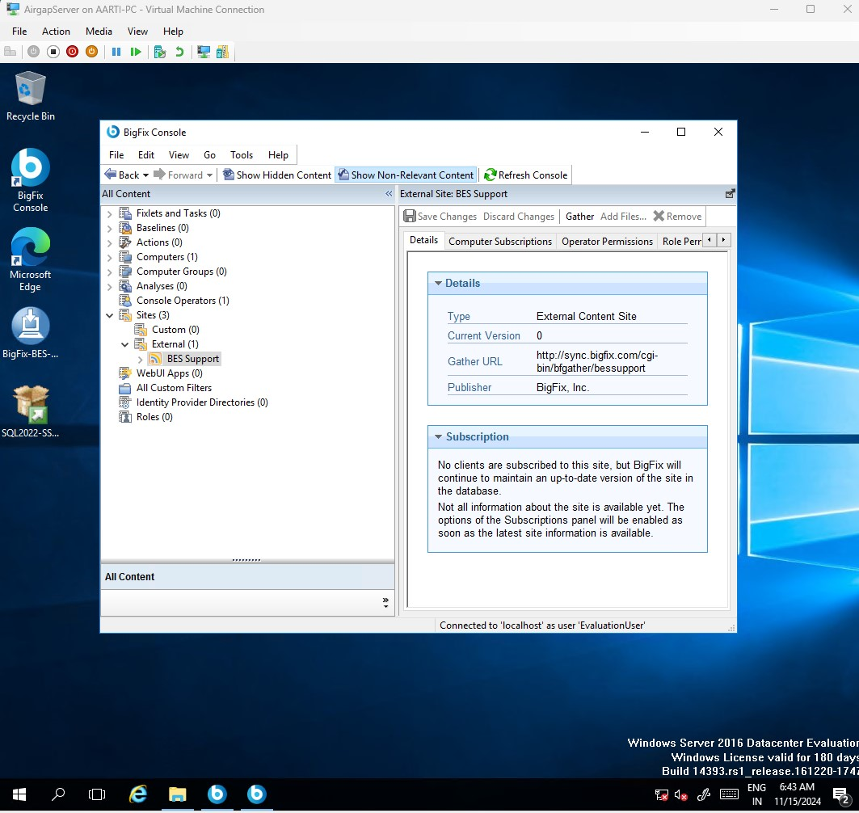

Next Step

* Run the Give command from the below image on the machine which has internet. It Gather list of all the site present in BigFix only Lists.
* Use your Serial number and Email Address accordingly
* .\BESAirgapTool.exe -serial 152325293 -email [akshay-ku@hcl.com](mailto:akshay-ku@hcl.com)
* .\BESAirgapTool.exe -serial 152325293 -email akshay-ku@hcl.com -createSiteList bigfixsites.txt

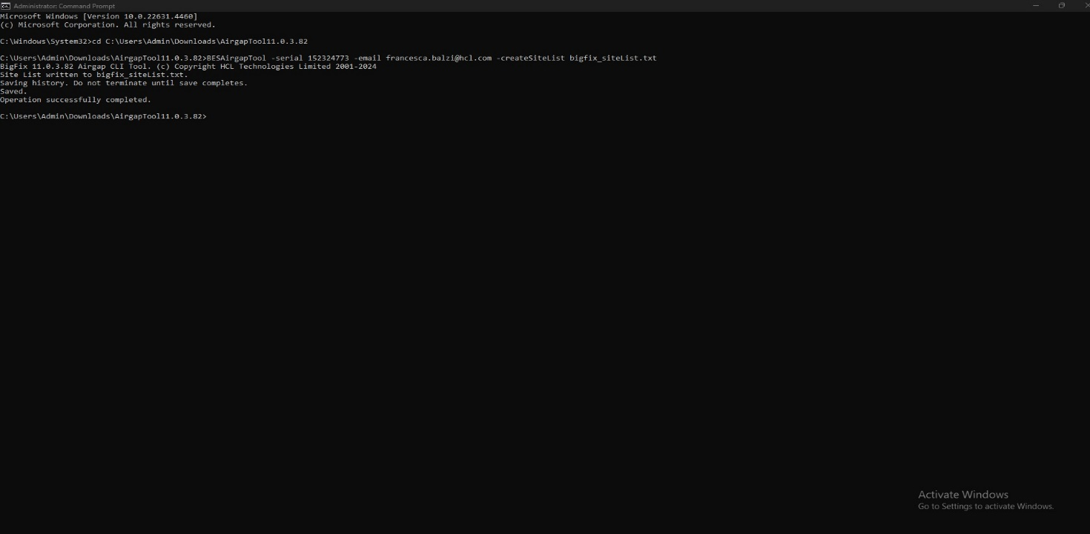

Next Step

* Run the Give command from the below image on the machine which has internet. It Gather Content of BES Support site.
* .\BESAirgapTool.exe -site bigfixsites.txt

* Kindly Refer below image for the specific task needed.

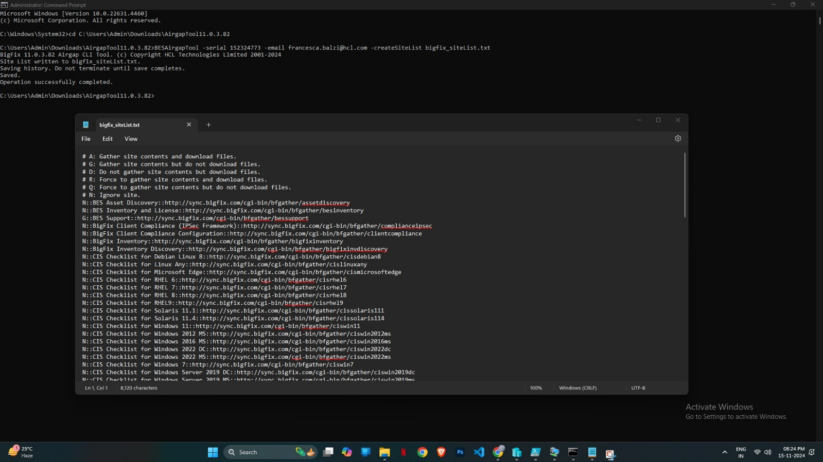

Next Step

* Copy the Airgap Tool Folder to Airgap Server Environment

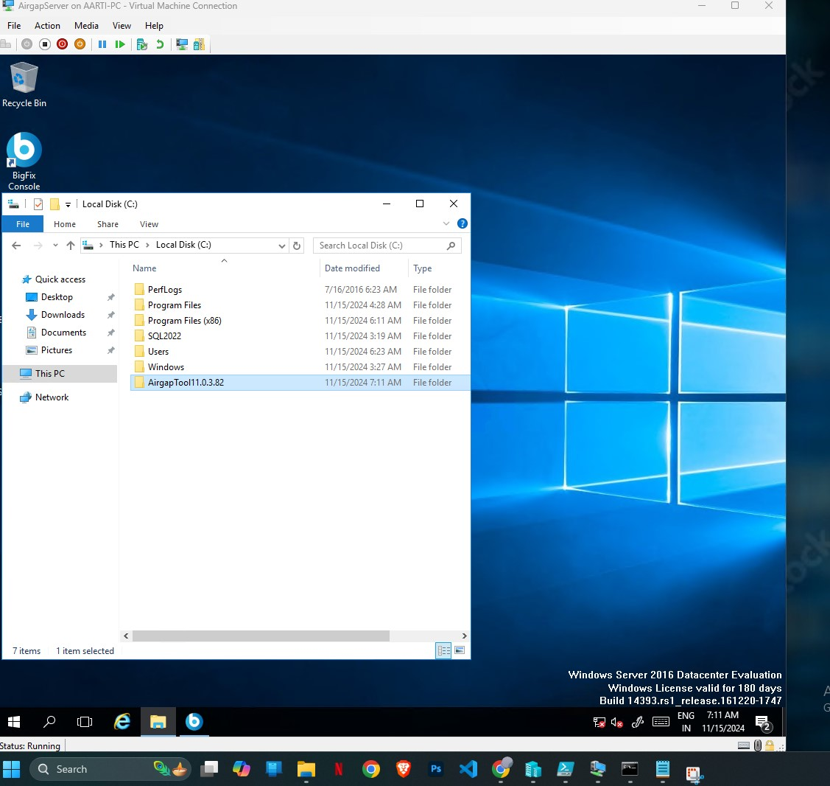

* Now We will Start importing Gather BES Support Site Content on Airgap Server Environment using below command

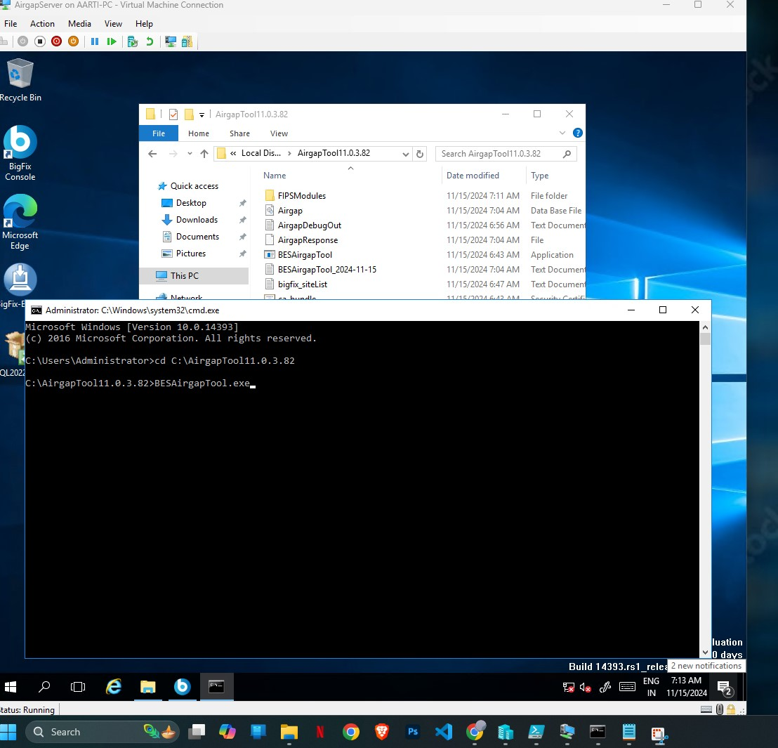

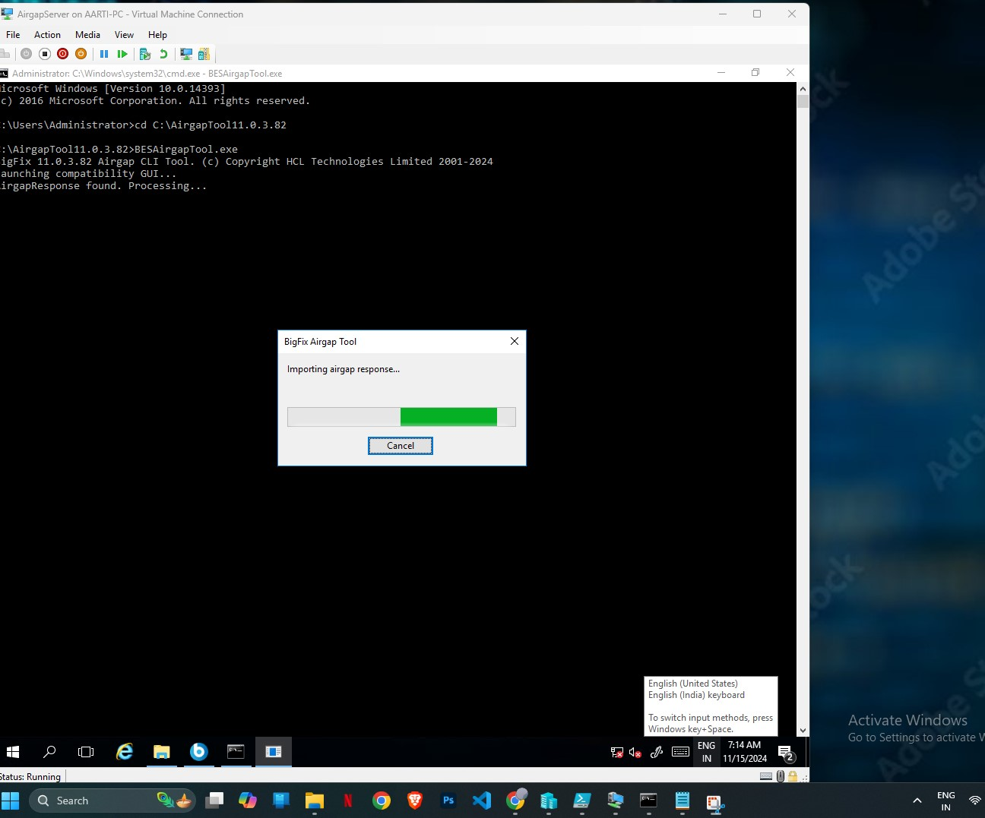

* Successfully imported BES Support Site Content.

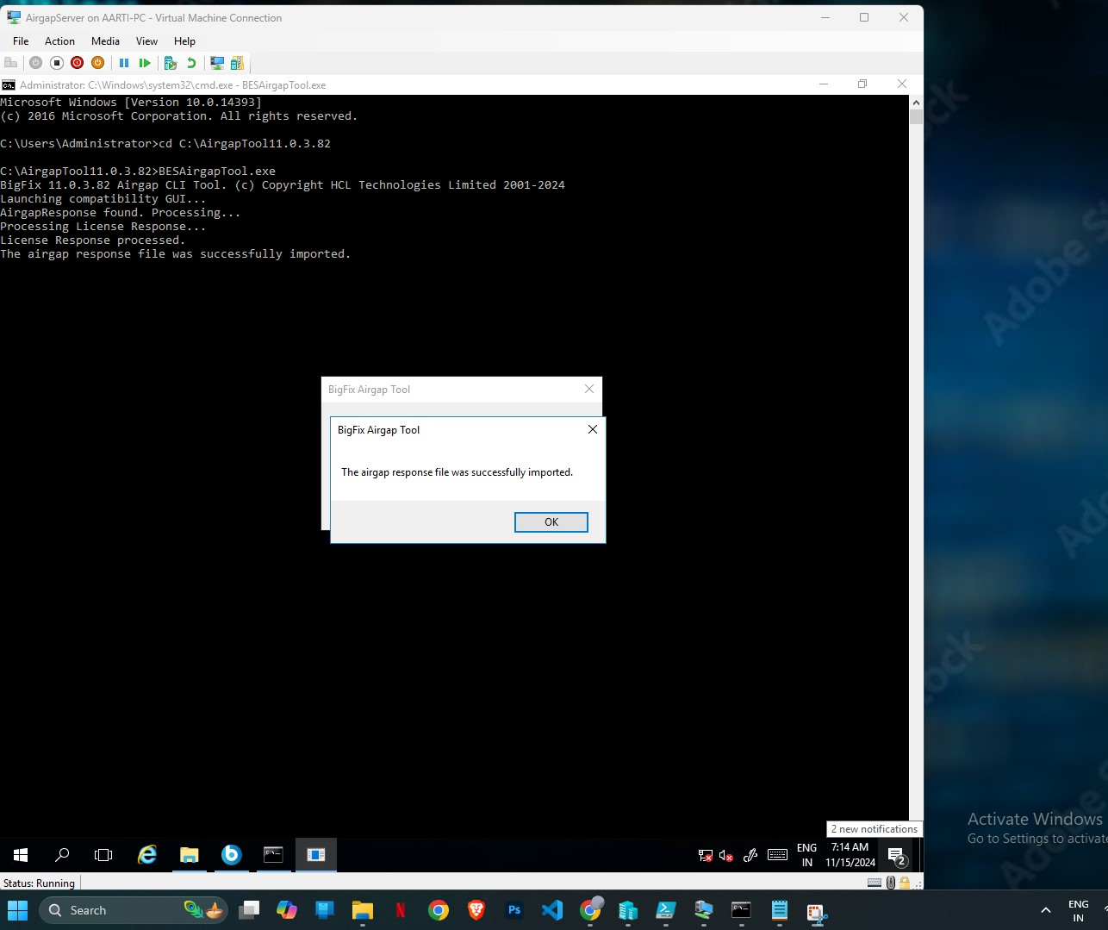

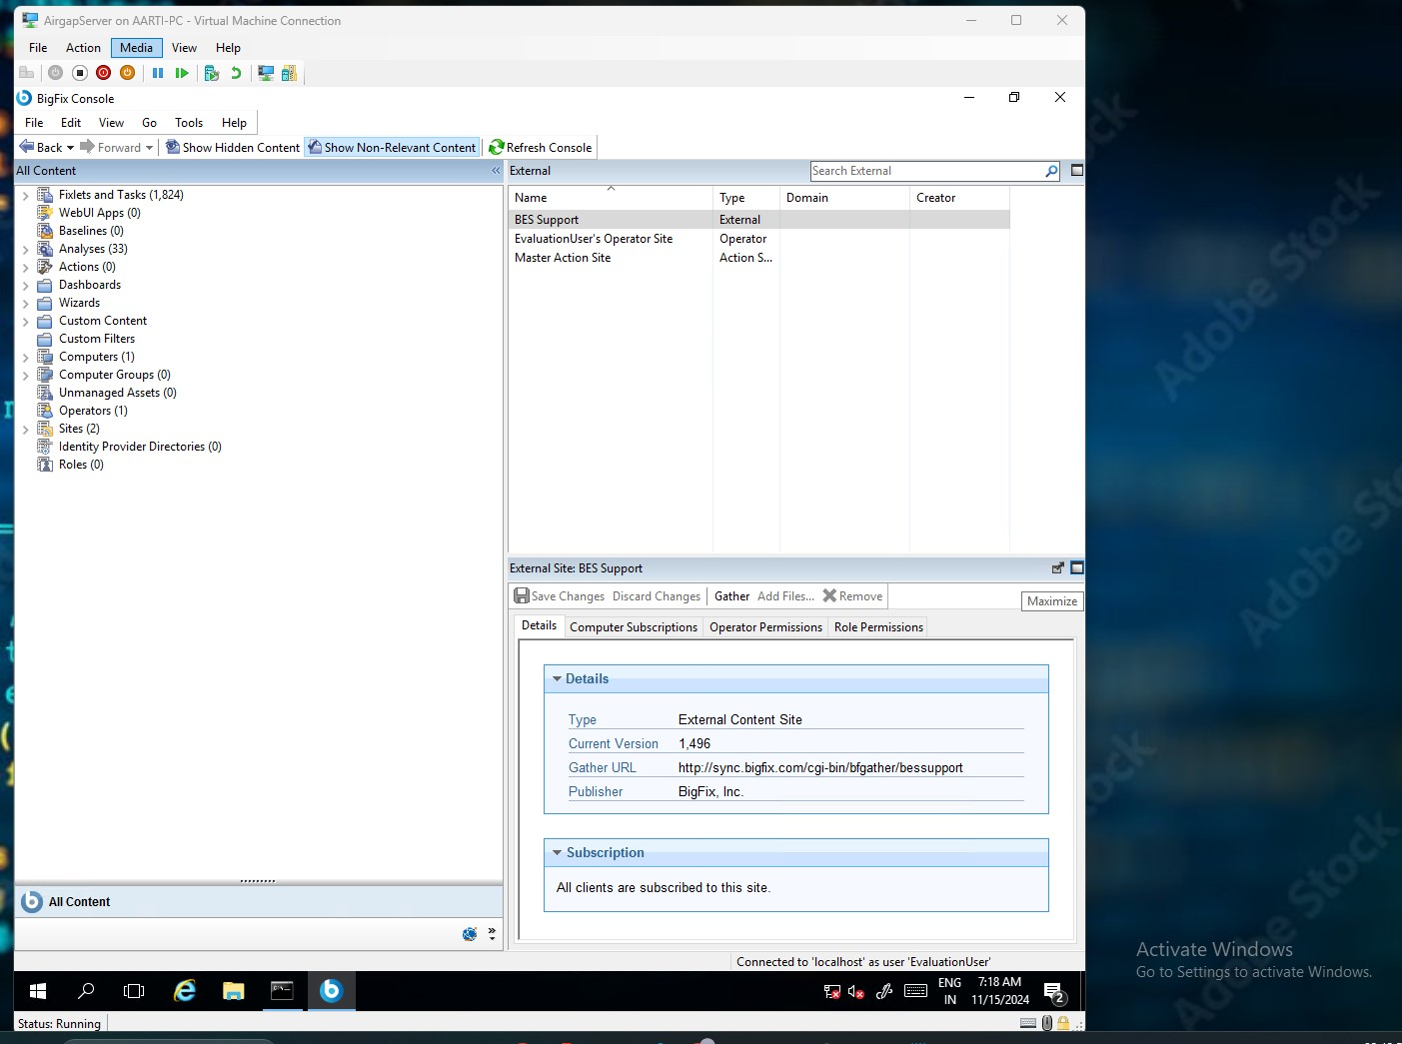

Gather Other Sites

Prerequisites

* Download Airgap Tool Utilities from download.bigfix.com on the machine which has internet and extract it.
* Then Go to console BigFix Patch Management.
* Enable Site of Your Choice

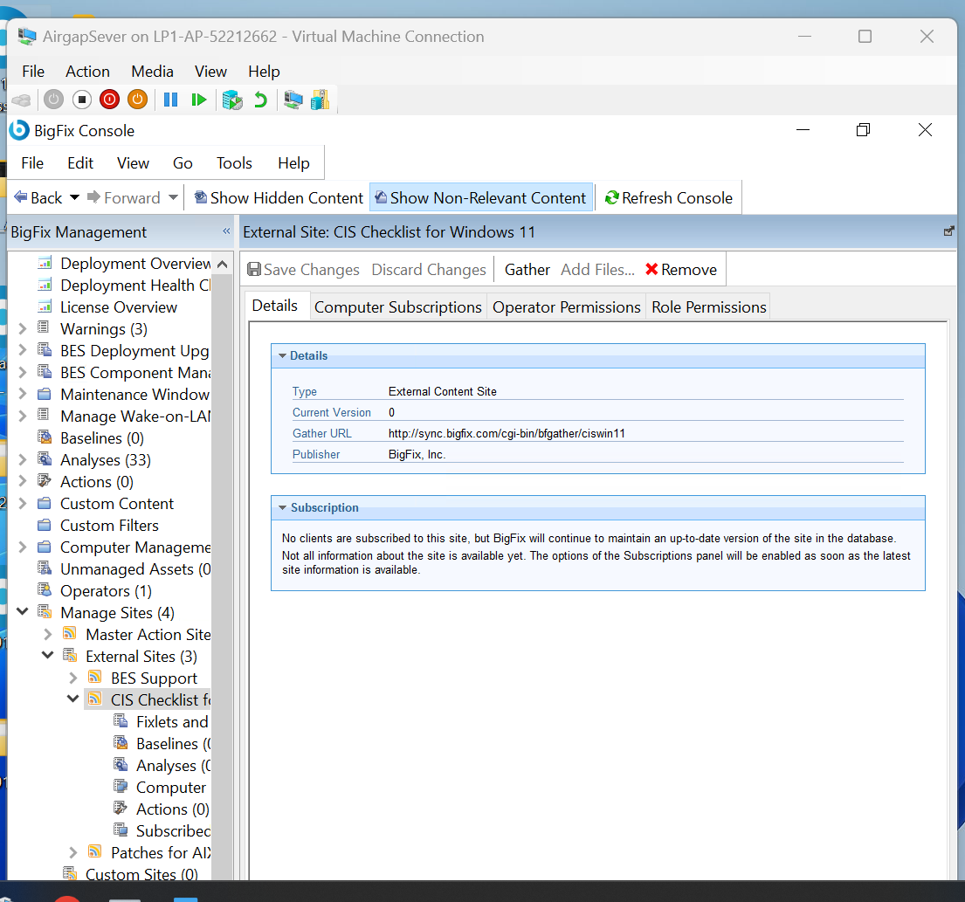

* Run the Give command from the below image on the machine which has internet. It Gather List of all available site in Bigfix

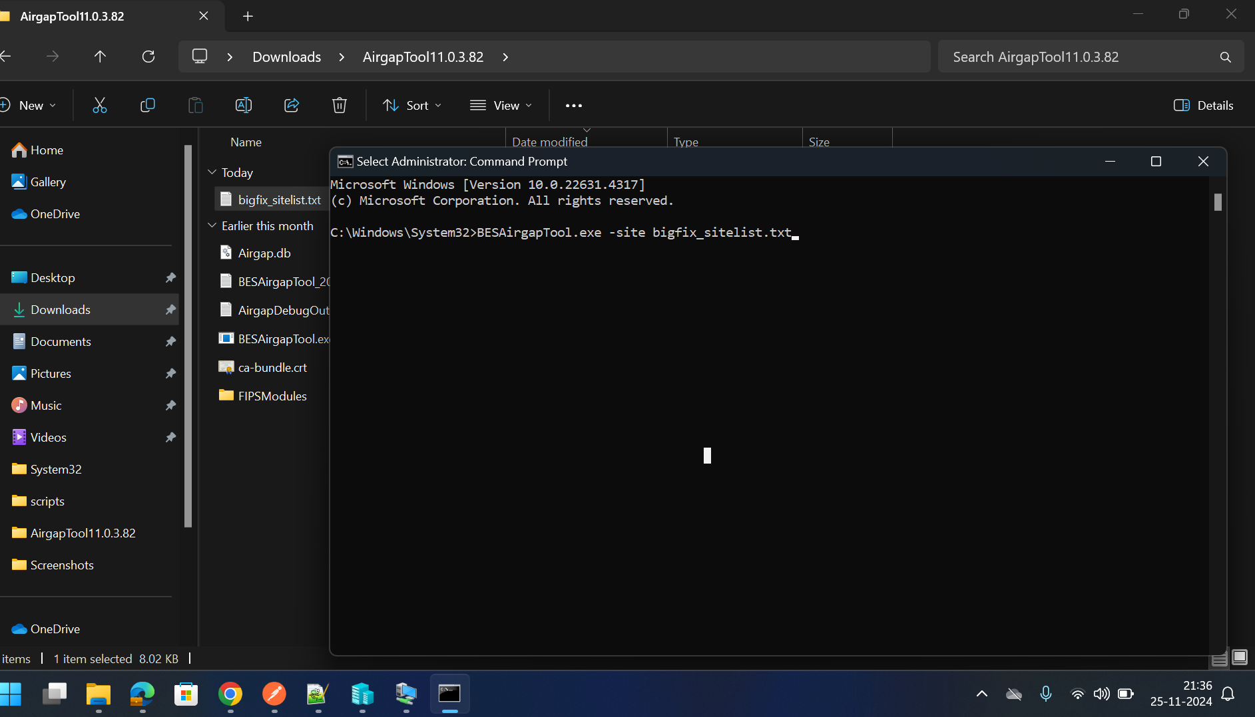

* Change N to G to Gather Content of Site you enabled in BigFix Console

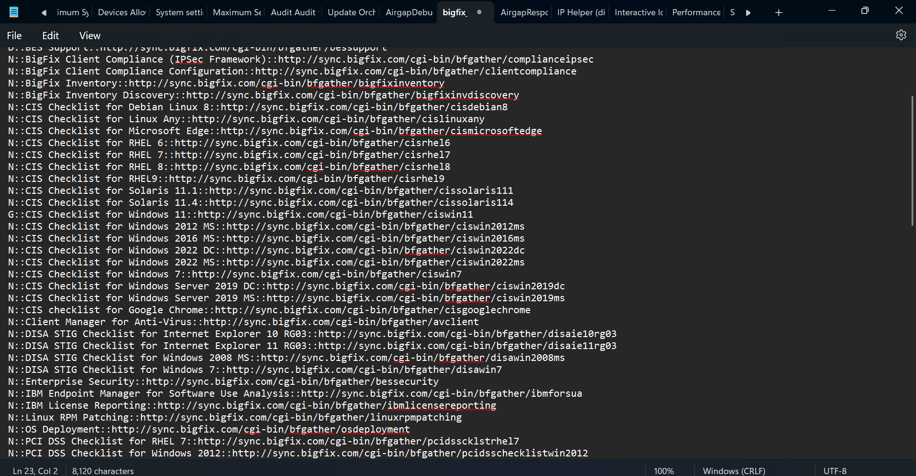

* Now We will Start importing Gather BES Support Site Content on Airgap Server Environment using below command. Copy the Airgap Tool Folder To Airgap Server Environment





* Successfully imported BES Support Site Content.



* 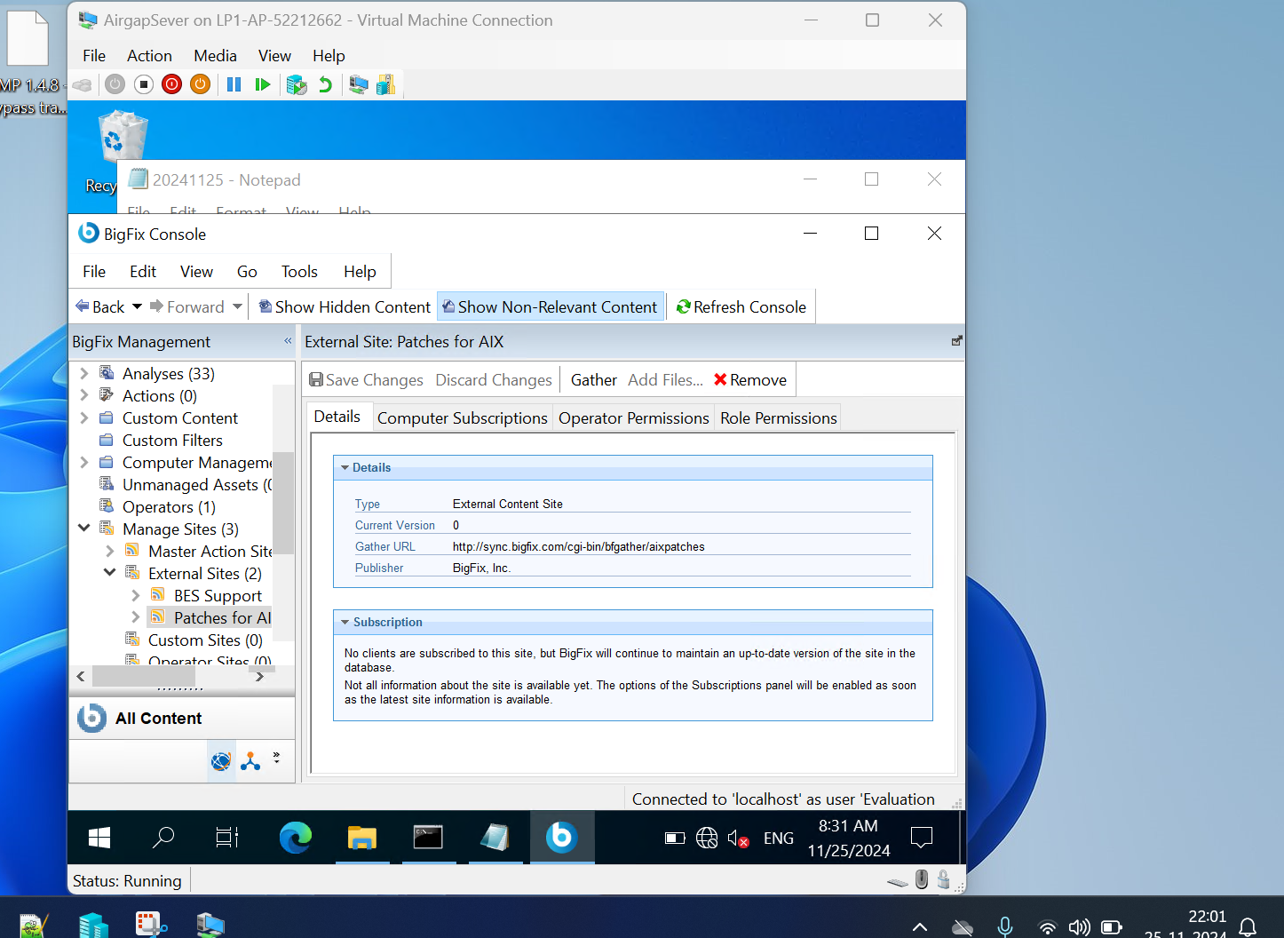Here I have Gathered Patches for AIX site.

File Downloads

Prerequisites

* Download Airgap Tool Utilities from download.bigfix.com on the machine which has internet and extract it.
* Then Go to console BigFix Patch Management.
* Enable Site of Your Choice

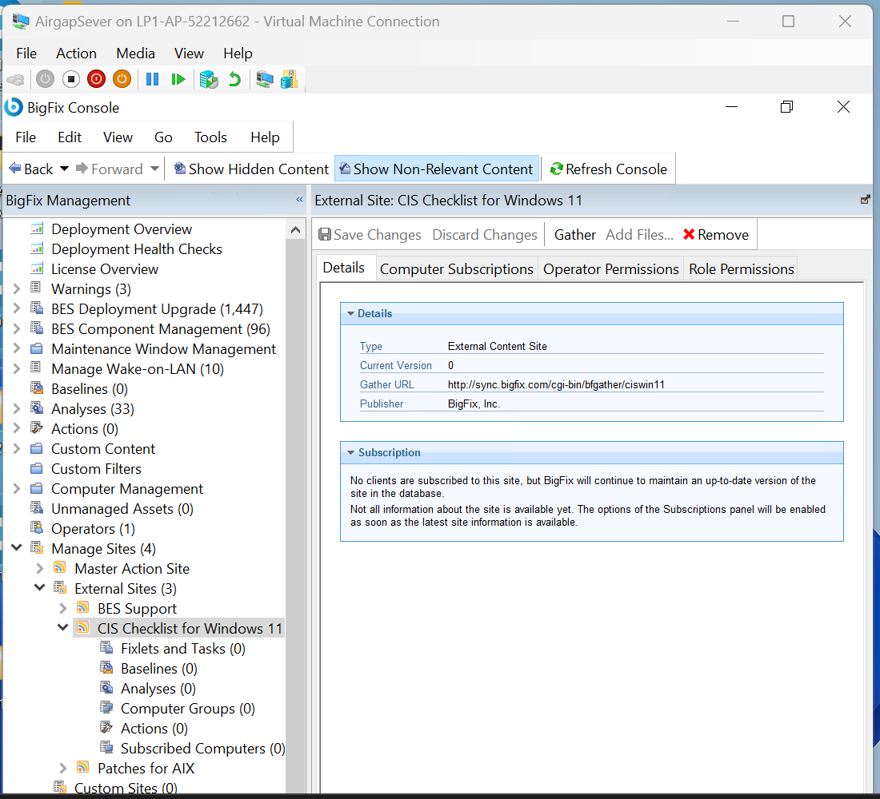

* Change the Site of Your Choice from N to D to Download the Patches

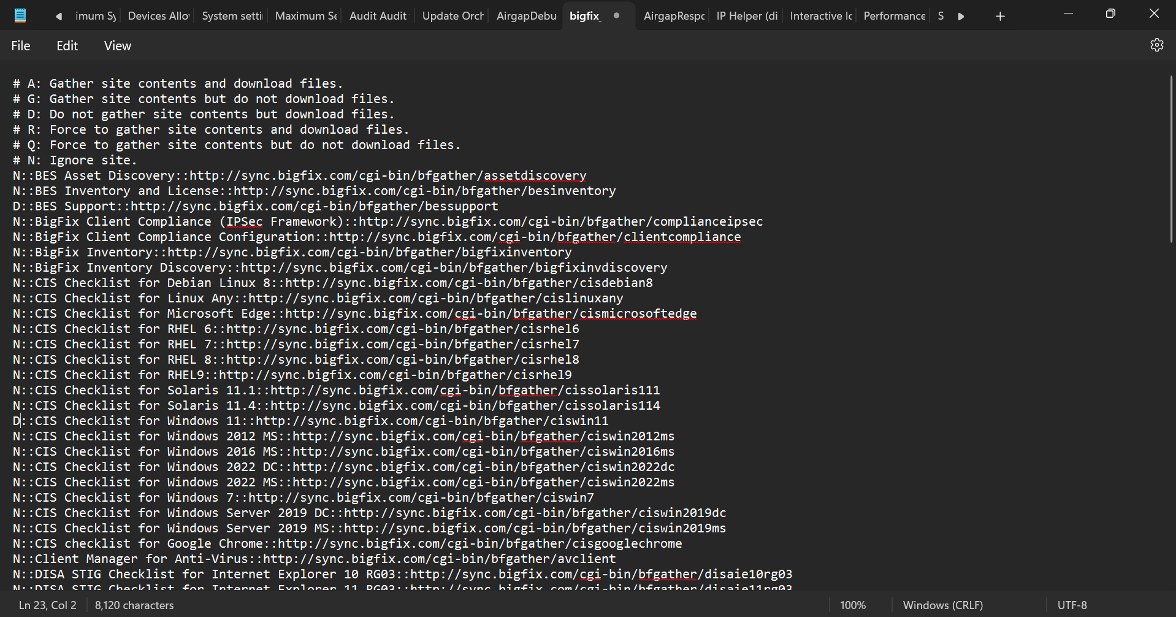

* After that Delete Airgap Response file From Airgap Tool Folder and then Run the below commands to download the patches.

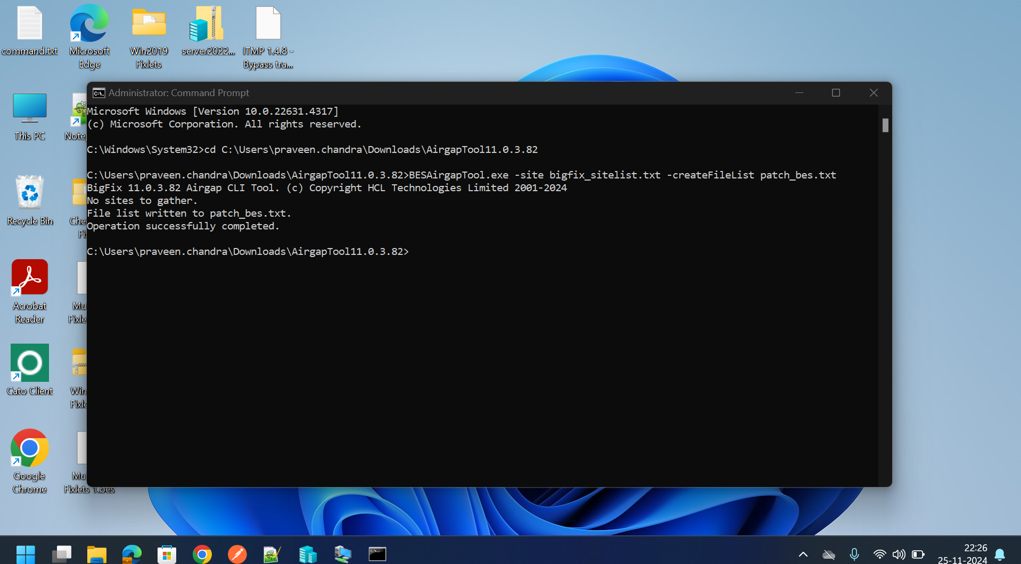

* Here I have downloaded patches for BES Support Sites. Now Choose Fixlets of your choice

.\BESAirgapTool.exe -site bigfixsites.txt -createFileList download.txt

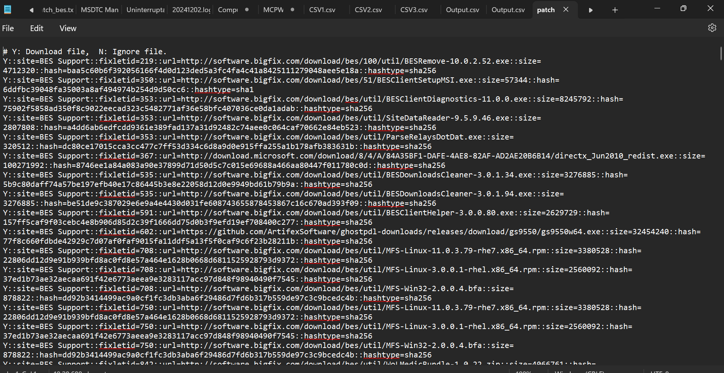

* Here I want to patch particular this fixlet so select the fixlet and remove other fixlet list

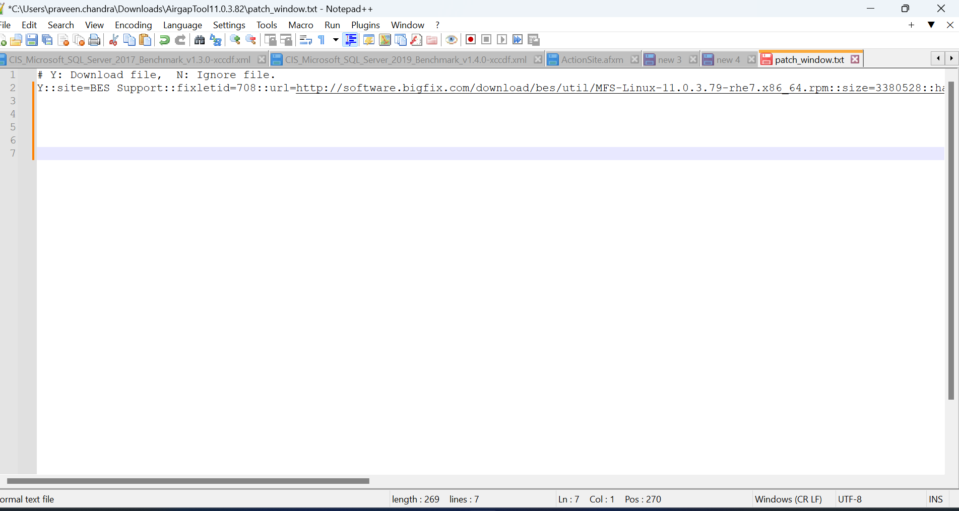

* Now save this file in Airgap Tool Folder I have saved it with name of download_files.txt

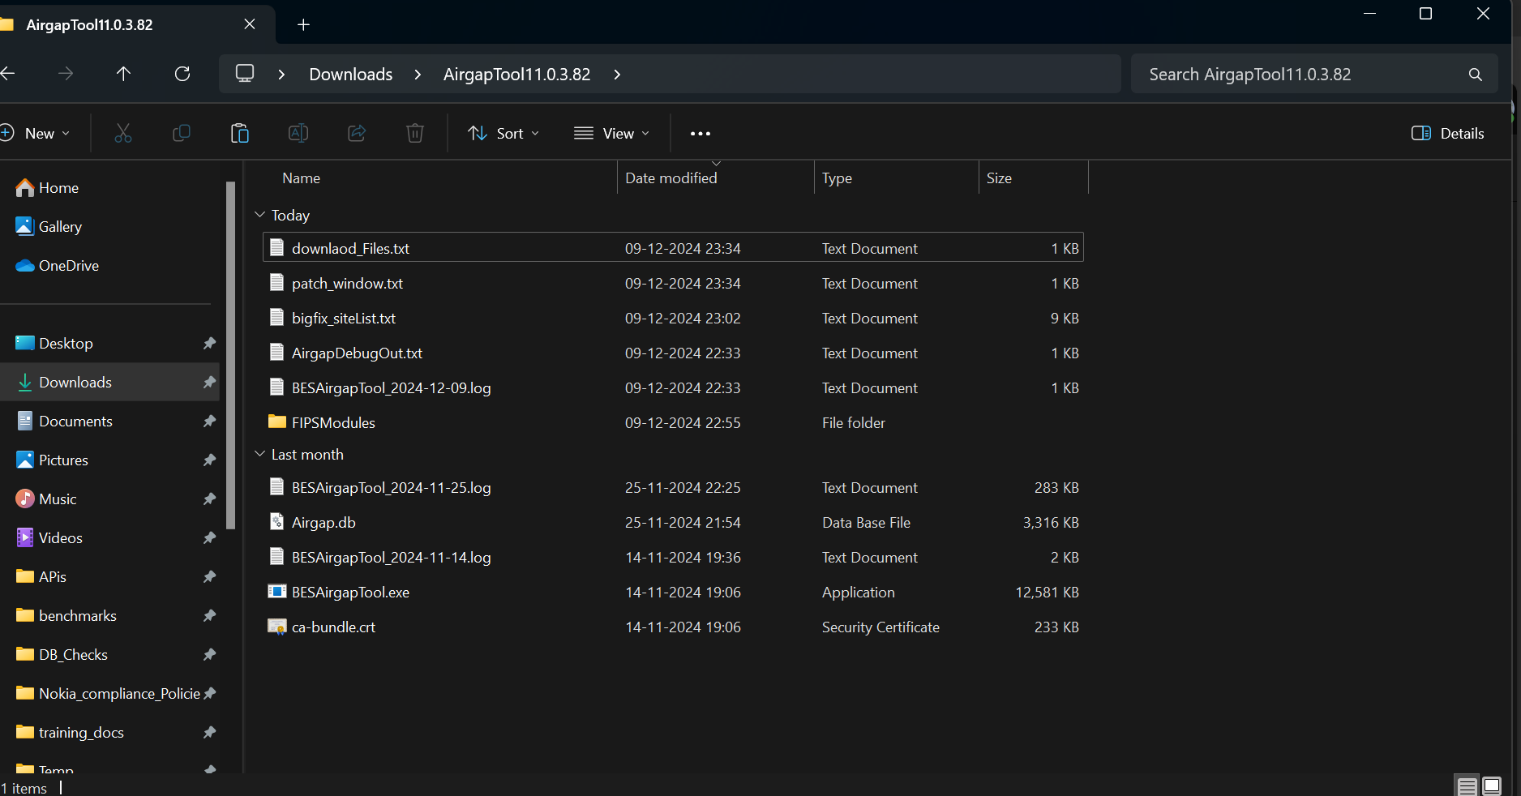

* Now Run the below command to download that particular fixlet it will create a cache folder copy it to Airgap Folder on Airgap Server

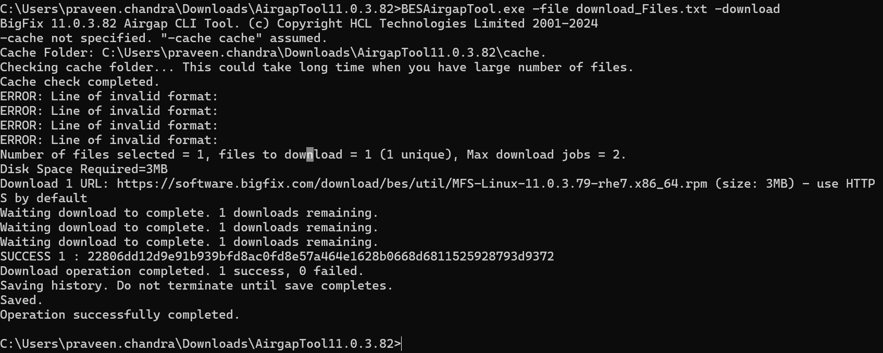

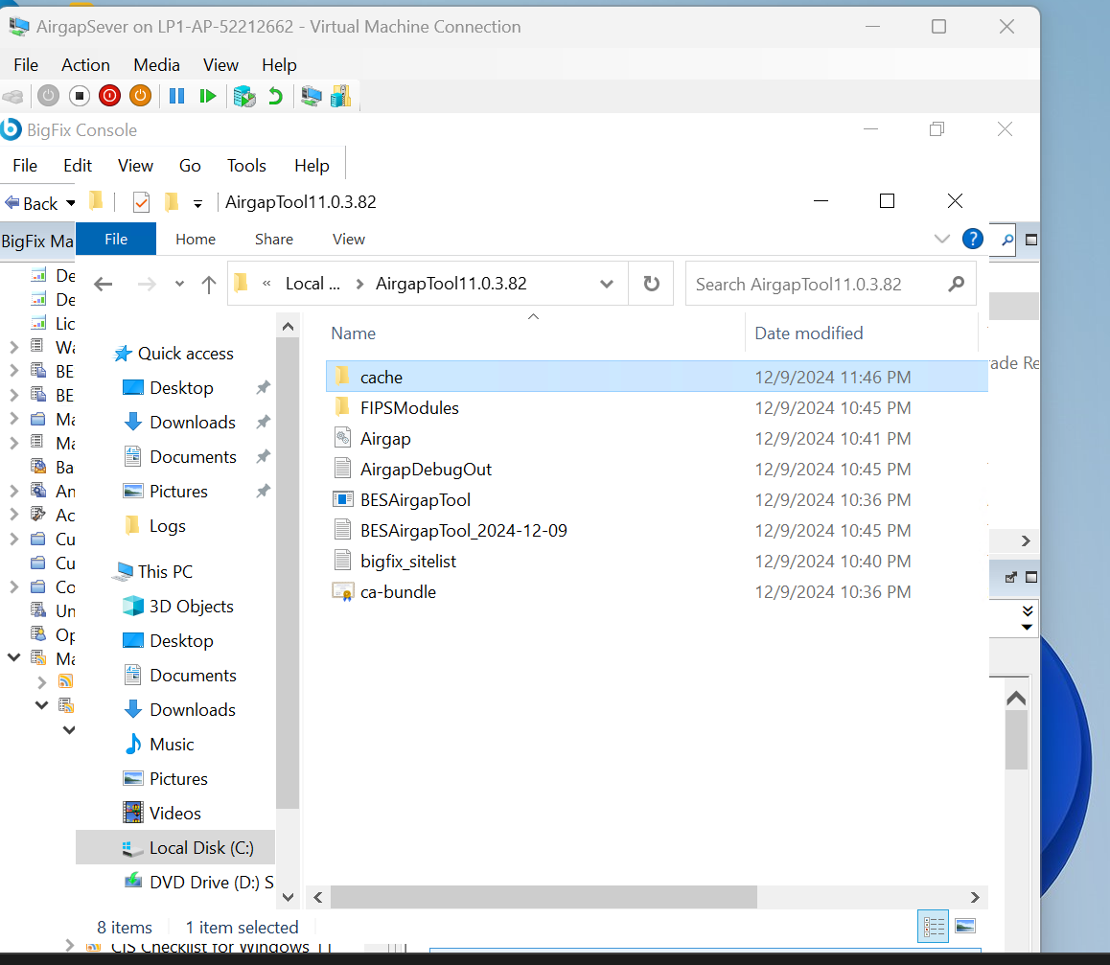

* Now copy the file present in the cache folder to { C:\Program Files (x86)\BigFix Enterprise\BES Server\wwwrootbes\bfmirror\downloads\sha1 } on Airgap Server

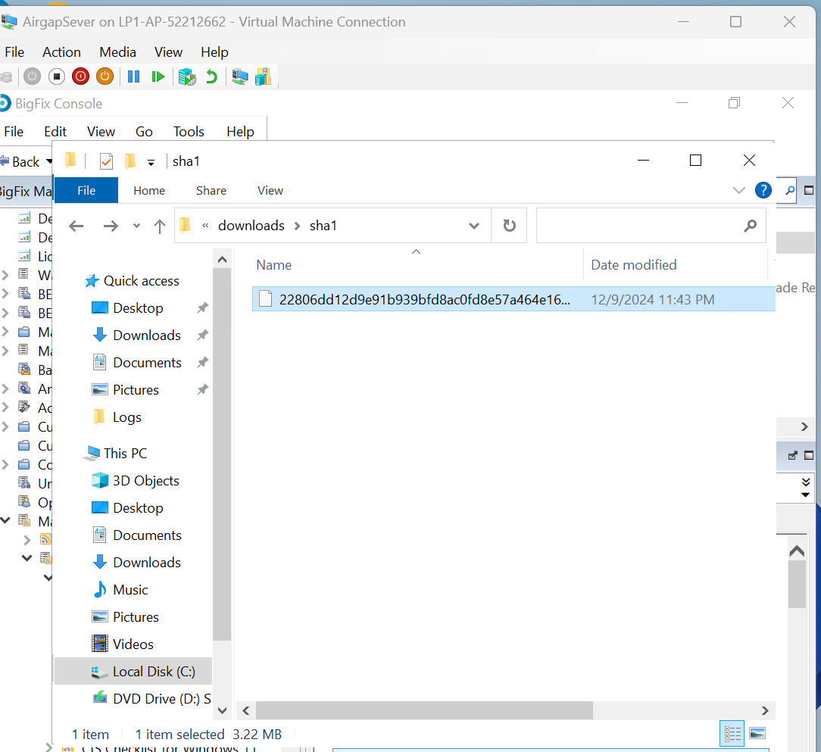

* Now you will able to take action on that particular fixlet from console

